BRITISH ASSOCIATION FOR KOREAN STUDIES

BURSARY COMMITTEE

The British Korean Veterans Association / Samsung
Study Year Abroad Bursary
Academic Session 2018/2019

The British Korean Veterans Association through the Bursary Committee of the British Association for Korean Studies is offering bursaries to undergraduate students with UK nationality who are on programmes of full-time academic study in which the study of the Korean language is an integral part of the programme, and which requires the student to spend a full academic session or part-session in Korea receiving intensive language tuition for the period of stay in Korea. The bursaries are offered as a memorial to the service and sacrifice of British soldiers in the Korean War. Preference will be shown to descendants of British soldiers who fought in the Korean War.
As the funds currently available are limited, the number and amount of the bursaries distributed by the Bursary Committee will be restricted. No restriction is placed, however, as to how the bursary will be used by the student. It may be applied to transport, maintenance, or some other use related to your year in Korea. As the bursaries will be highly competitive, only applicants whose performance in language study is at or above the Upper Second Degree Class level will be considered. In order to differentiate between students whose language attainment is similar, the Committee will also pay attention to academic attainment in non-language subjects. Financial need will be considered after consideration of academic attainment.

Interested students should apply by doing the following:

- Complete the application form below, including the Data Protection Form at the end.
- Obtain two (2) letters of recommendation from tutors or lecturers. One of the referees should be able to speak about your attainments in the study of the Korean language, while the other referee should be able to discuss your attainments in the non-language elements of your degree course.

Applications and letters of recommendation (Testimonials) must be mailed to the address below. Information must be inserted into the Application Form and the Data Protection Form and these must carry signatures. Testimonials must use the Testimonial form below and carry signatures. If applications or Testimonials do not arrive in the proper form or without signatures or after the deadline, they will not be considered. Completed applications and letters of recommendation should be emailed to:

Dr. James Lewis, Chair
BAKS Bursary Committee
jay.lewis@orinst.ox.ac.uk

All materials must be received by the Committee no later than 6 April 2018. All applicants will be informed of the Committee’s decision within four weeks.

BRITISH ASSOCIATION FOR KOREAN STUDIES

BURSARY COMMITTEE

The British Korean Veterans Association / Samsung
Study Year Abroad Bursary

APPLICATION FORM

Instructions for application: Complete all sections of the form. Send the form along with two (2) letters of recommendation to:

Dr. James Lewis, Chair
BAKS Bursary Committee
jay.lewis@orinst.ox.ac.uk

Your application for a bursary should be received by the Committee no later than 6 April 2018.

--Full Name (Please print, and then underline surname):

--Are you a member, spouse, or descendant of HM Forces, and in particular, connected by relation to those who hold or held the UK Korean Campaign Medal and/or the United Nations Medal?

--Contact Address (Please print):

Telephone:
Mobile Telephone:
Email Address:
Institution:

--Degree Course Title:

--Level or Year in University Course:

On a separate sheet of paper, write a short statement of your programme of study and your academic and personal interests in Korea and any special financial requirements. Please indicate how you intend to use the award. Please limit your statement to between 300 and 500 words. Your application must be signed, either physically or with a digital signature.

Signature: Date:

BRITISH ASSOCIATION FOR KOREAN STUDIES

BURSARY COMMITTEE

The British Korean Veterans Association / Samsung
Study Year Abroad Bursary

TESTIMONIAL
(Language Instructor/Lecturer)

Name of Applicant (please print):

Name of Recommender (please print):

Institution:

Instructions: Please write a frank appraisal of the applicant’s language ability and overall performance in the language elements of his/her study. Please indicate any marks available and any predicted. Use more than one sheet of paper if required. Testimonials must use the Testimonial form below, be emailed, and carry digital signatures. If applications or Testimonials do not arrive in the proper form or without digital signatures or after the deadline, they will not be considered. Unsigned letters will not be accepted. All correspondence must be received by the Committee no later than 6 April 2018. Address all correspondence to:

Dr. James Lewis, Chair
BAKS Bursary Committee
jay.lewis@orinst.ox.ac.uk

Signature: Date:

BRITISH ASSOCIATION FOR KOREAN STUDIES

BURSARY COMMITTEE

The British Korean Veterans Association / Samsung
Study Year Abroad Bursary

TESTIMONIAL
(Lecturer in Non-language Subjects)

Name of Applicant (please print):

Name of Recommender (please print):

Institution:

Instructions: Please write a frank appraisal of the applicant’s abilities. Please indicate any marks available and any predicted. Use more than one sheet of paper if required. Testimonials must use the Testimonial form below, be emailed, and carry digital signatures. If applications or Testimonials do not arrive in the proper form or without digital signatures or after the deadline, they will not be considered. Unsigned letters will not be accepted. All correspondence must be received by the Committee no later than 6 April 2018. Address all correspondence to:

Dr. James Lewis, Chair
BAKS Bursary Committee
jay.lewis@orinst.ox.ac.uk

Signature: Date:

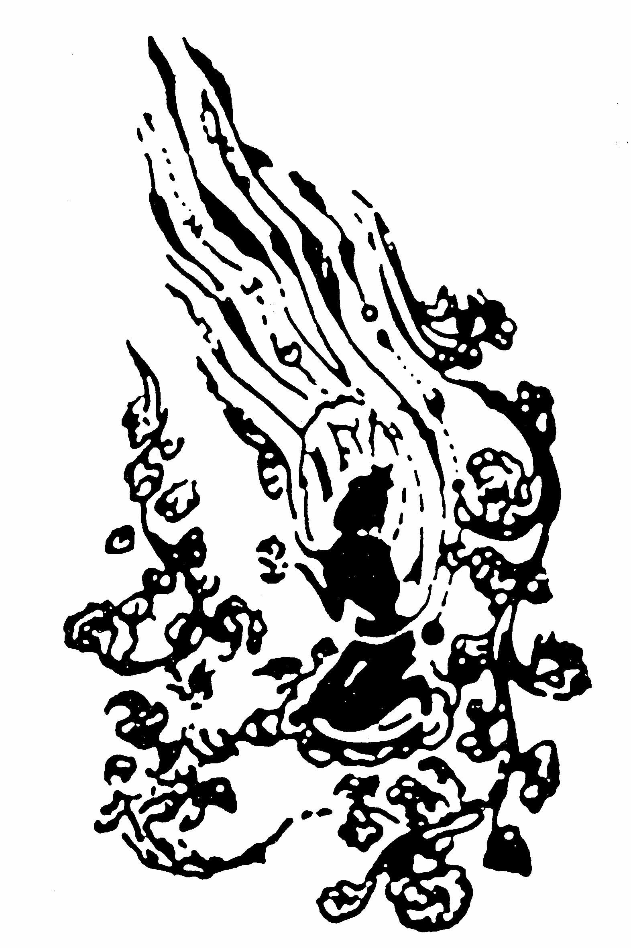
How we use your personal information

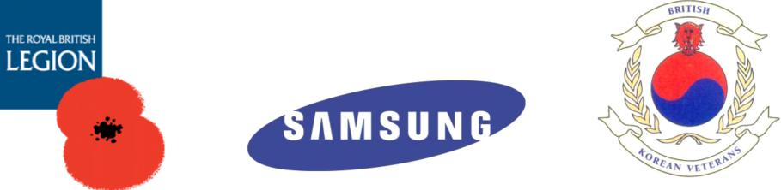
THE R(TYAL BRITISH
LEGION

The Royal British Legion and the British Association for Korean Studies (BAKS) are fully committed to respecting your rights and their duty to use your personal information lawfully, in line with the Data Protection Act 1998.
Your personal information will be:

- securely stored by the Legion and the Association and be used by Legion staff, BKVA Trustees, and BAKS Scholarship Committee Members to process your application and provide you with assistance
- shared with other charitable organisations & companies we work with to provide you with assistance
- used by the Legion, BKVA Trustee's, and BAKS Scholarship Committee Members to monitor and improve our services (by creating statistics, reports, and evaluations, as well as being audited by the Legion or our appointed representatives)

I agree that my personal information can be used as above:

Name:

Signature:

Date:

